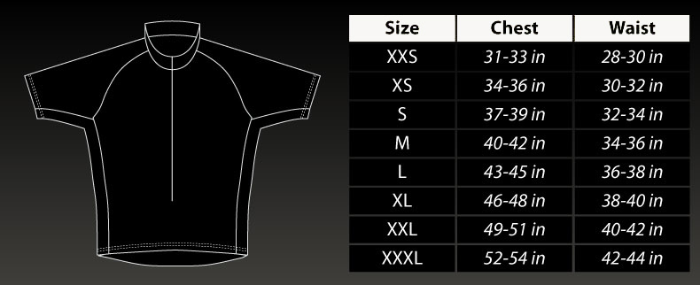
FEMALE CYCLING JERSEY SIZE CHART FULL HIDDEN ZIPPER $75.00
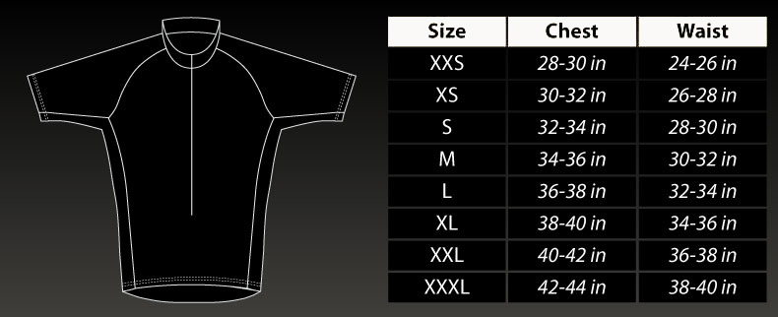
PRO CYCLING JERSEY SIZE CHART FULL HIDDEN ZIPPER $105.00

